Regression Analysis: Task
This section works out an example that includes all the topics we have discussed so far in this chapter.
A complete example of regression analysis.

PhotoDisc, Inc./Getty Images
A random sample of eight drivers insured with a company and having similar auto insurance policies was selected. The following table lists their driving experiences (in years) and monthly auto insurance premiums.

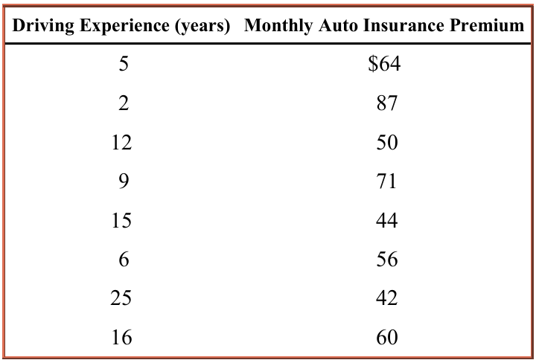

- Does the insurance premium depend on the driving experience or does the driving experience depend on the insurance premium? Do you expect a positive or a negative relationship between these two variables?
- Find the least squares regression line by choosing appropriate dependent and independent variables based on your answer in part a.
- Interpret the meaning of the values of a and b calculated in part c.
- Plot the scatter diagram and the regression line.

e) Calculate r and r²and explain what they mean.
f) Predict the monthly auto insurance premium for a driver with 10 years of driving experience.

